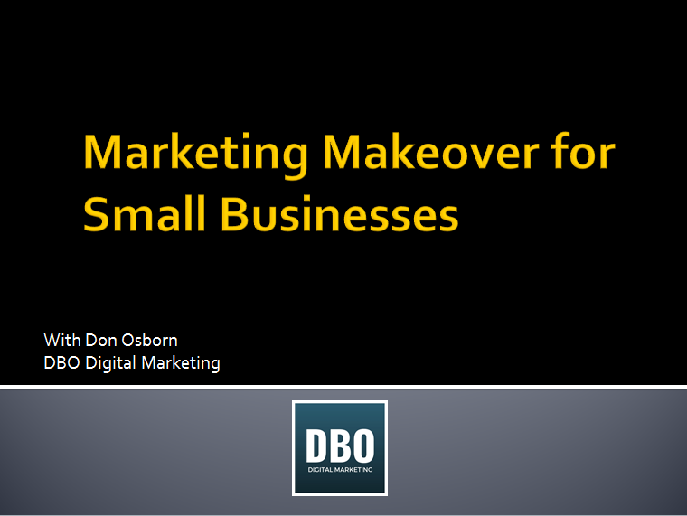

Steps 1 & 2:
Marketing Tool Kit
Checklist & Upgrade List

We will complete this list throughout the course of today’s workshop. Complete this checklist honest as things are today. Once complete, you will have a working checklist for what you need to bring your Marketing Tool Kit up to speed. This list is not absolutely complete, but it’s darn close.

Branding

 | Yes |  | No
1. | € | Does your company have a strong logo? | €
2. | € | Do you have image files? | €
3. | € | Clear branded indoor and outdoor signage? | €
4. | € | Branded business cards | €
5. | € | Branded letterhead | €
6. | € | Branded invoices | €
7. | € | Staff emails using your website domain (as opposed to Gmail or Hotmail) | €
8. | € | Professional photos for public facing staff | €
9. | € | Branded Promotional Items? (Includes swag, banners, car wraps, etc.) | €
10. | € | If yes, do you have a current inventory and reorder schedule? | €
11. | € | Written brand guidelines? | €

Stop

Website Management

12. | Website Speed |  | Target is 90-100
13. | Broken Links |  | Target is 0

 | Yes |  | No
14. | € | Do you know your website URL? | €
15. | € | Do you know your domain provider? | €
16. | € | Do you have access to your domain account? | €
17. | € | Do you know who hosts your website? | €
18. | € | Do you have access to your website hosting account? | €
19. | € | Are you an “admin” on your website? | €
20. | € | Does your site have an SSL certificate (https)? | €
21. | € | Is your website fast enough? | €
22. | € | Does your website have any broken links? | €
23. | € | Do you have an activated Google Analytics account? | €
24. | € | Do you have an activated Google Search Console account? | €
25. | € | Do you have a website baseline? | €
26. | € | Do you have a website reporting system? | €

Stop

Website Appeal

While these questions are somewhat subjective, give it an honest shot:

 | Yes |  | No
27. | € | Visually Appealing | €
28. | € | Mobile-friendly (test on your phone) | €
29. | € | Has a Favicon | €
30. | € | No Interruptions (auto play videos or audio) | €
31. | € | Easy To Read | €
32. | € | Uses Visuals | €
33. | € | Minimal Stock Photos | €
34 | € | Minimal Drop Down Boxes | €
35. | € | Clickable logo top left | €
36. | € | Clear company name | €
37. | € | Call to Action on each page | €
38. | € | Clickable phone number near top | €

Website Content Quality
 | Yes |  | No
51. | € | Website Appeal | €
52. | € | Clear Promise in Title? | €
53. | € | Fulfill Promise in Content? | €
54. | € | No Jargon? | €

Stop

Search Engine Optimization / Google My Business

55. | Homepage Word Count
56. | Product / Service Page Word Count

 | Yes |  | No
57. | € | Does your site have a dedicated SEO manager? | €
58. | € | Have you claimed your Google MyBusiness Account? | €
59. | € | Do you have a Google Review link code that you can send to customers for reviews? | €

Hometown search using SERPS tool

Keywords | Google Maps Top 3  Yes/no | Google 1st Page  Yes/no
1.
2.
3.

A town 30 miles away, same keywords using SERPS Tool

Keywords | Google Maps Top 3  Yes/no | Google 1st Page  Yes/no
1.
2.
3.

Data Management

 | Yes |  | No
60. | € | Do you have an accurate customer list? | €
61. | € | Do you use a CRM or Business System? | €
62. | € | Do you have a dataflow system? | €

Stop

Email Marketing

 | Yes |  | No
63. | € | Do you use email marketing? | €
64. | € | If so, what email provider do you use? | €
65. | € | Do you have an email opt-in on your website? | €
66. | € | Do you have a current customer list? | €
67. | € | If so, does it include email addresses? | €

Stop

Social Media

 | Yes |  | No
68. | € | Do you have a "Like" buttons on your website for all social properties? | €
69. | € | Do you have a Facebook Business Page? | €
70. | € | Do you have a LinkedIn account? | €
71. | € | Do you have a YouTube channel? | €

Stop

Digital Tools

 | Yes |  | No
72. | € | Do you currently use LastPass (or another password vault) | €
73. | € | Online Payment Portal? | €
74. | € | Cloud-based drive (Gmail, Dropbox, etc.)? | €
75. | € | Auto scheduler | €

Stop

Advertising
Digital
 | Yes |  | No
 |  | Check the digital advertising methods that you use
76. | € | Banner ads | €
77. | € | Pay per Click | €
78. | € | Google Adwords | €
79. | € | LinkedIn ads | €
80. | € | Facebook boosts | €
81. | € | Facebook ads | €

Traditional
 | Yes |  | No
 |  | Check the digital advertising methods that you use
82. | € | Radio | €
83. | € | Print | €
84. | € | TV | €
85. | € | Outdoor | €
86. | € | Direct Mail | €
87. | € | Do you know your annual cost for each ad format? | €
88. | € | Do you have any media contracts? | €
89. | € | Do you track results of these ads? | €
90. | € | If so, do you know the ROI for each ad campaign? | €
91. | € | Do you use any co-op funding for these ads? | €

Stop

Donations/Goodwill

 | Yes |  | No
92. | € | Do you have a donation policy and budget? | €

Planning

 | Yes |  | No
93. | € | Do you have a Marketing Budget? | €
94. | € | Do you have a current Marketing Plan? | €

Stop

Your Marketing Toolbox Inventory is Complete!
Just for fun, add up how many no’s you have checked. This will give you a starting point…
I hope this exercise gives you useful information as to what you can do to upgrade your marketing Toolbox. While this list is not absolutely complete, it will give you a great starting place to make some upgrades.
You now have an actionable checklist of what needs added or upgraded in your Marketing Tool Box.
On each page you will see footnotes with suggestions and available support.
Good luck!

Step 3:
Marketing Plan
Worksheet

Elevator Pitch

You know [problem] ________________________________________________________?

Well, what we do is [solution] ________________________________________________.

In fact, [proof]. ______________________________________________________________.

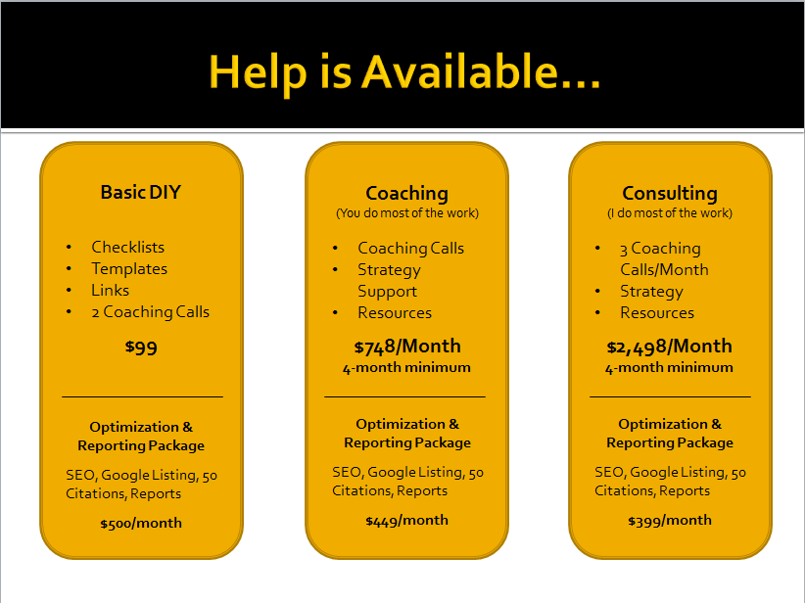

Suggested file types: PNG, JPEG, PDF, EPS
https://www.canva.com/learn/your-brand-needs-a-visual-style-guide/
If no, consider this package: https://www.dbodigitalmarketing.com/services.html
If no, consider this package: https://www.dbodigitalmarketing.com/services.html
Opt-in for the DBO Digital Marketing mailer, and I’ll send you this link free of charge.
We suggest https://www.insightly.com/
We suggest https://mailchimp.com/
We suggest https://www.lastpass.com
We suggest https://calendly.com/
If no, lets talk. Book a call here: https://calendly.com/donald-b-osborn

